1. Why this project is done?
This project is done to analyze real-world Data Analyst job market trends and understand salary patterns. It helps job seekers and recruiters make data-driven career and hiring decisions.

2. Explain my app.py code clearly (10 lines, simple)
The app.py file loads and cleans the job market dataset using Pandas.
It extracts salary and skill information from raw data.
The code performs exploratory data analysis using visualizations.
A machine learning model is trained to predict salaries.
Streamlit is used to create an interactive web interface.
The sidebar enables navigation between different sections.
Charts and graphs are displayed dynamically.
User inputs are collected using sliders and checkboxes.
Salary predictions are generated using the trained model.
Results are displayed instantly on the web application.

3. Explain Dashboard, EDA Analysis, Salary Prediction, and Conclusion in Streamlit output
Dashboard:
Displays overall job market summary such as total jobs, average salary, and top roles.
EDA Analysis:
Shows visual insights like salary distribution, top sectors, and high-paying locations.
Salary Prediction:
Allows users to input job parameters and predicts average salary using ML.
Conclusion:
Summarizes key insights, findings, and usefulness of the system.

4. Why these sections are important for viva?
These sections demonstrate end-to-end implementation from data analysis to deployment.
They show practical application of analytics, machine learning, and real-world problem solving.

5. What is the dataset for this project?
The dataset contains over 2000 Data Analyst job listings collected from Glassdoor via Kaggle. It includes salary estimates, job roles, locations, company ratings, sectors, and job descriptions.

6. Who are the users of this product and who are the producers of this project?
The users of this product are job seekers, recruiters, and data analysts. The project is designed and developed by an individual data analyst (student) as an academic and analytical solution.

7. Will this project work for job seekers or is it built only for individual use?
This project is useful for job seekers to understand salary trends and required skills. It is built by an individual but can be used by multiple users through the Streamlit application.
8. Does this project need maintenance over time after production?
Yes, the project requires periodic maintenance to ensure smooth functioning and compatibility with updated libraries. Minor updates may be needed for performance improvement and feature enhancement.

9. Does this project need dataset upgradation if launched as a product?
Yes, regular dataset updates are necessary to reflect current job market trends. Updated data improves prediction accuracy and relevance for users.

10. Will this product be useful for large job portals like Naukri and Indeed?
Yes, the analytical framework can support large job portals by providing insights and salary benchmarking. However, large platforms would require real-time data integration and scalable infrastructure.

Result:
1. Dashboard
The dashboard provides an overall summary of the Data Analyst job market. It displays total job count, average salary, and most common job roles using interactive visualizations.
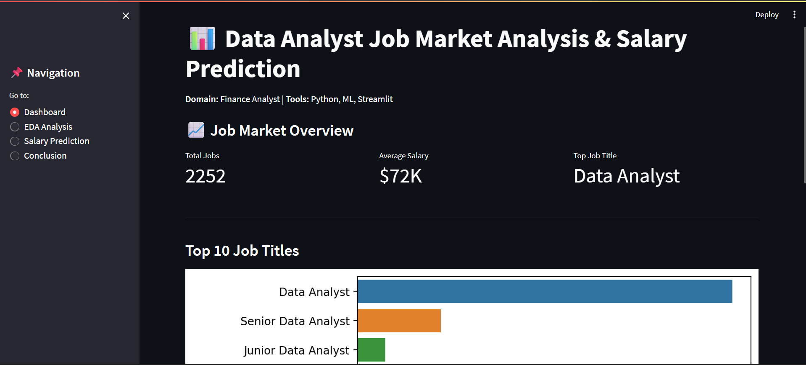
2. EDA Analysis
This section presents exploratory data analysis through charts and graphs. It highlights salary distribution, top-paying sectors, and high-paying job locations.

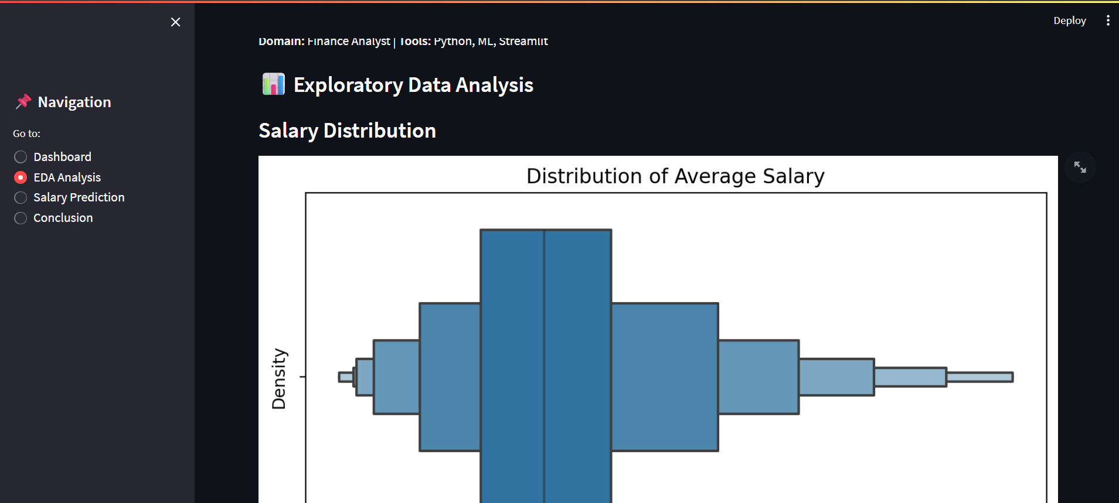
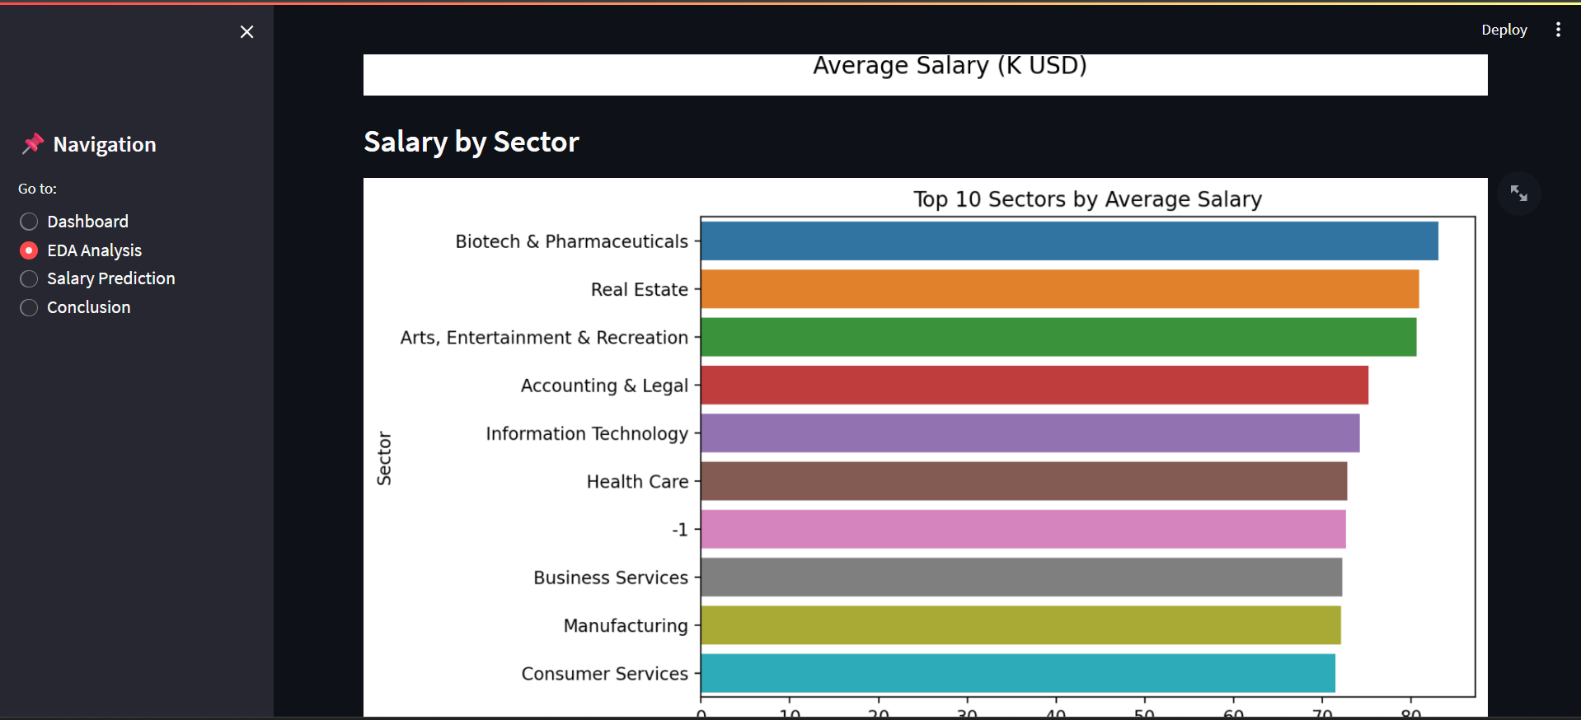
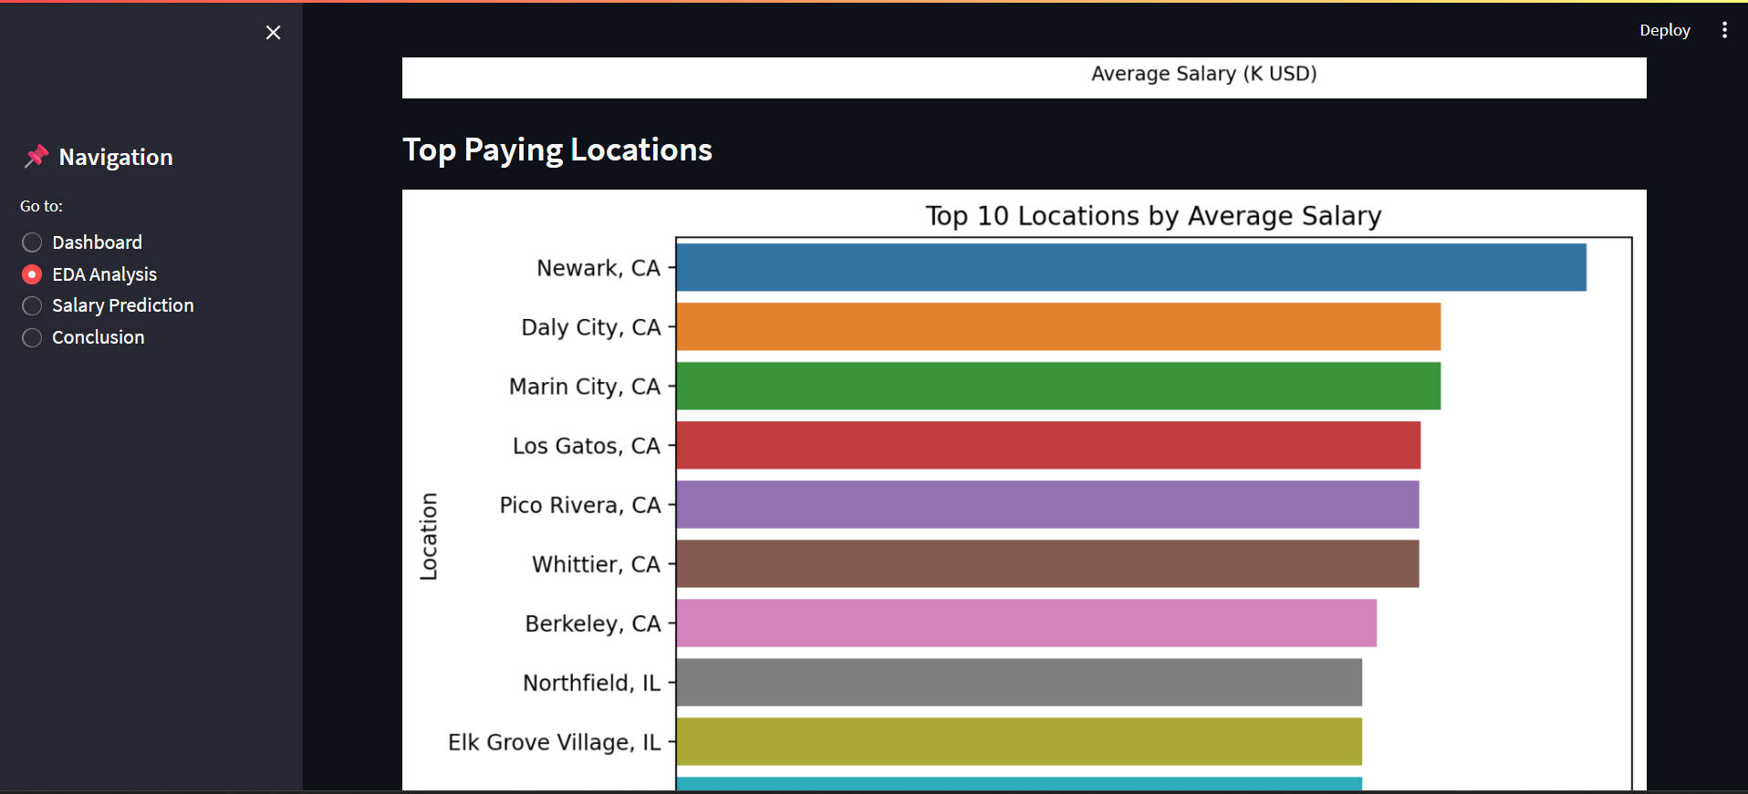

3. Salary Prediction
The salary prediction module uses a machine learning model to estimate average salary based on company rating and required skills. User inputs are processed in real time to generate predicted salary output.
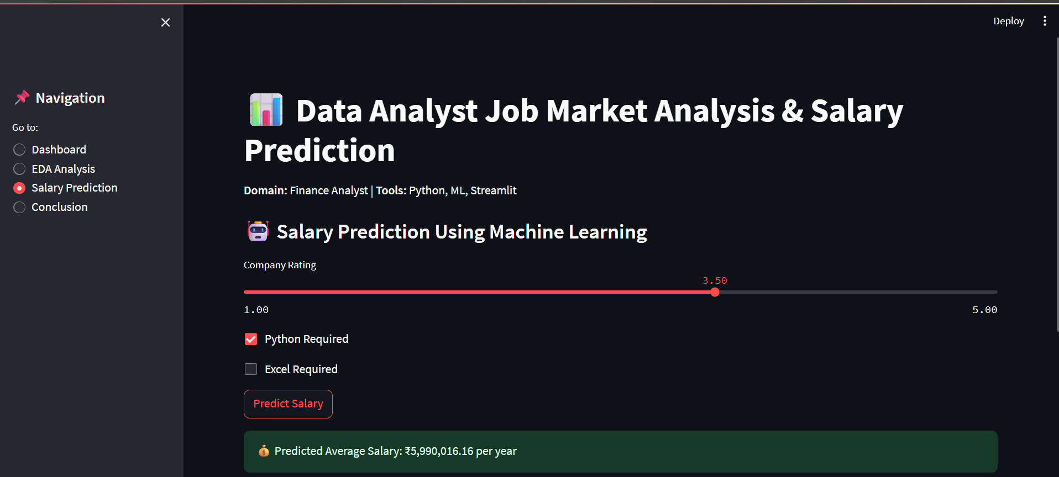
4. Conclusion
The conclusion screen presents the summarized insights obtained from job market analysis and salary prediction. It highlights key findings and allows users to download the dataset and project notebook for further reference.
